Draft proposal content/structure for manuscript:

**Possible Title: High beta-diversity of woodland species predicts farmland abandonment to positively affect macro-moth diversity at the landscape-scale.**

**Possible outlets:** Journal of Applied Ecology (IF 4.7), Basic and Applied Ecology (IF 2.7), Ecography (IF 5.1)…

**Authors:** Merckx, Miranda, Corley & Pereira (not a sine-qua-non to include Martin Corley as a co-author but I know he would greatly appreciate this gesture; his input was essential in getting the species IDs 100% correct)

**Scope:** to show alpha and beta diversity patterns of macro-moths at multiple spatial scales within a context of farmland abandonment

**Design/Data:**

Two sampling years: 2011 + 2012

84 fixed sampling sites (see Map (pdf) and coordinates (xls)), each sampled 6 times repeatedly (3 times/year)

[The coordinates of the 84 sites are in degrees (I believe within the WGS84 projection) and converting them to the Portuguese grid system (either Hayford Gauss IPCC (Datum 73) or Hayford Gauss IGeoE (Datum 73)) would allow calculating pairwise distances among all trap combinations, or maybe this can be done directly from the degrees coordinates too? Anyway, check that trap sites closest to one each other (e.g. trap 1 and trap 2) are 60m apart.

Three study landscapes (1.64km2 each) representing a farmland abandonment gradient: meadow-dominated landscape / shrub-dominated landscape / forest-dominated landscape

In each landscape we sampled four biotopes: meadow / short shrub / tall shrub / woodland:

|  |  |  |  |  |
| --- | --- | --- | --- | --- |
| ***Number of sites*** | Meadow-dominated landscape | Shrub-dominated landscape | Forest-dominated landscape | TOTAL |
| Meadow | **13** | 4 | 1 | 18 |
| Short Shrub | 7 | **9** | 5 | 21 |
| Tall Shrub | 6 | **11** | 2 | 19 |
| Woodland | 2 | 4 | **20** | 26 |
|  | *28* | *28* | *28* | *84* |

Four spatial scales each:

20 x 20 m (0.04 ha; light trap placed in centre; attraction radius ca. 10m) 28*3 = 84 plots

80 x 80 m (0.64 ha) 4*3 = 12 plots

320 x 320 m (10.24 ha) 4*3 = 12 plots

1280 x 1280 m (163.84 ha) 1*3 = 3 plots

22.825 individuals

377 species (of which 4 species aggregates: I propose it’s ok we include these in the analyses, isn’t it?)

**Data:** CompleteDataset_forLaetitia.xls

This dataset gives counts (Nr) of each species for each site/date and allows lumping data at scales larger than single sites: columns ‘Landscape’, ‘Scale320320’ and Scale8080’.

For each species we have the following variables:

* Family
* Subfamily
* Genus
* Min wingspan (mm) (literature)
* Max wingspan (mm) (literature)
* Dominant feeding niche: grass/herbs/heather/shrub/lichens/trees (literature)
* Biotope: open/mix/forested (literature, BUT our own data may be better!)
* Specialism: Oligo versus polyphagous larvae
* Voltinism: uni/bi/multivoltine (adult generations per year) (literature)
* Distribution size: S/M/L/XL/XXL (literature)
* Rarity: rare/average/widespread: based on number of 10K squares within Portugal

So, if we’d want we could check if species with differing traits display other diversity patterns….

I propose to address both alpha and beta diversity in the paper.

1. **Alpha diversity**: we could give similar figures as the three figures from my chapter (Fig. 6.3a,b, c) in the Rewilding book (attached), but now backed up with statistical tests (I can take care of those).

So I would test (regression):

Fig 6.3a: Local Species richness = Biotope Landscape and their interaction: Biotope x Landscape

Fig6.3b: Species Richness = Spatial scale (4 classes) Landscape and their interaction

Fig. 6.3c: Species Richness = Spatial scale (5 classes) Open/Closed species group (or an index for openness based on our own data) and the interaction.

Do we perform this last analysis via grouping species into open versus closed biotope species based upon literature data (as is done within the rewilding chapter) or shall we do this grouping (two groups) based on our own records (e.g. fig. below which gives for 216 species their proportion for 4 biotopes (with abundances equal or larger than 7; in analogy to that recent Nature paper on bats: Mendenhall et al 2014)? The latter may be better, but then we would have to delete species for which we have too few records…. In both cases, I’d like to contrast groups that are really different, so would prefer to not take into account intermediate species so as to be sure we’re contrasting ‘extremes’.

This figure may actually be nice to include too, as it clearly shows that the large majority of species use several biotopes! Henrique is going to like this :)

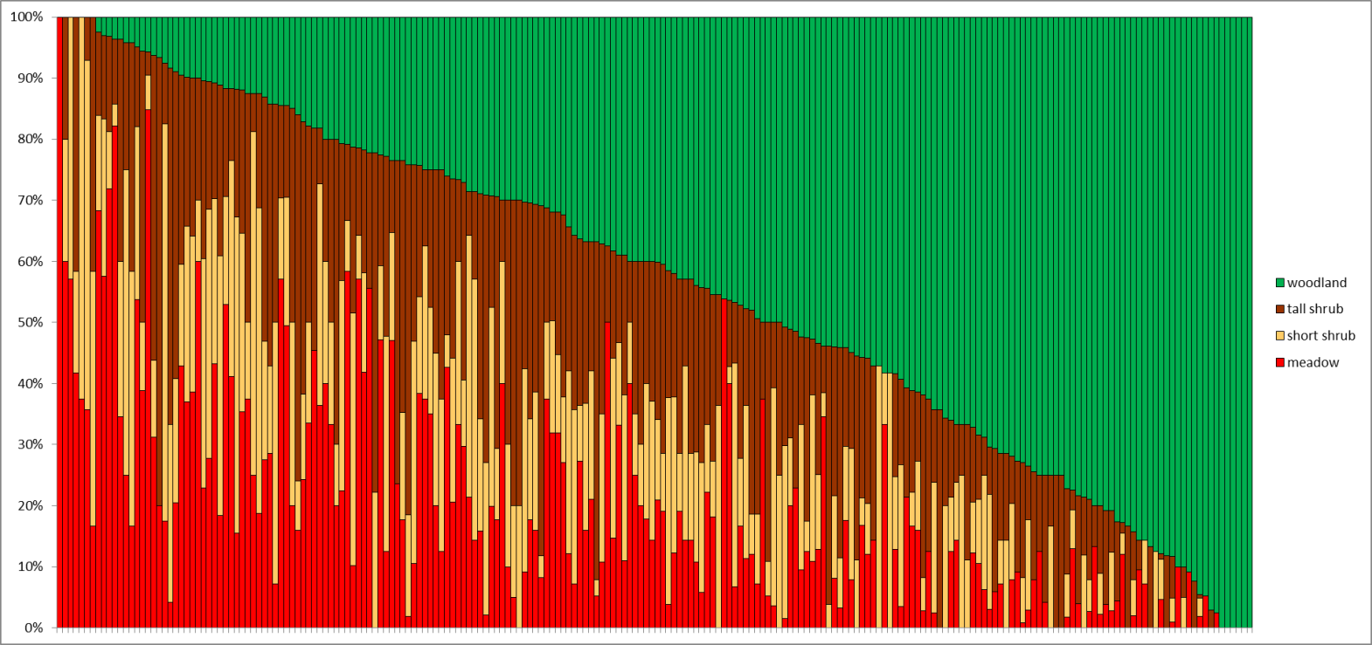

1. **Beta diversity:** Murilo!?

* Pairwise distances among all 84 trap sites need to be calculated in order to study species turnover with distances
* Karp et al (2012, Ecol. Lett.) should be our example to follow (+ read Anderson et al (2011, Ecol. Lett.))
* So, based on Karp et al 2012:
  + I would go for Pairwise dissimilarity in species composition between all trap combinations, with a dissimilarity estimator that uses sample size (N) and accounts for unseen species (Chao et al 2005)
  + I would also go for average dissimilarity at three or four spatial scales, each time separately for each of the four biotopes (similar to Fig. 1 in Karp et al 2012). The scales being: 80x80m, 320x320m, landscape-scale, and maybe a fourth scale in which we lump the two landscapes that are furthest from one each other?
  + Regression of site dissimilarity against distance: providing slopes and R-squares (similar to Fig. 2 in Karp et al 2012; remark here that I believe there is a mistake in the caption of this Figure 2: the last sentence should state that the variance increased! And not decreased with intensification?!) (+ bootstrapping? + check bias due to variation in species richness?): We could contrast the four biotopes and also contrast the three landscapes, which will give nice figures.

I think this could be a really nice and novel study, as the few previous studies on beta diversity and spatial scale (Gabriel et al 2006 Ecol. Appl.; Flohre et al 2011 Ecol. Appl., Karp et al 2012) show homogenizing effects of agricultural intensification, whereas we here could be the first(?) to show that extensive agriculture too has a homogenising effect (probably less than intensive agriculture, but still strong when compared to the re-naturalised situation, which also goes to show that studies should include the natural habitat situation too). Also, while Karp et al 2012 show that diversity at large spatial scales is similar in forest and extensive agricultural land, I believe that our findings will contrast strongly with this.

Looking forward to your thoughts on this and on how to proceed,

Abraço,

Thomas